EXPERIMENT 8 : Insertion Sort with Duplicate Elements
Aim:
To write a Python program to implement Insertion Sort on an array containing duplicate elements and analyze its time complexity.

Algorithm:
- Start.
- Read or define an array containing duplicate elements.
- Consider the second element as the key.
- Compare the key with the elements before it.
- Shift the elements that are greater than the key one position to the right.
- Insert the key into its correct position.
- Repeat the process for all remaining elements.
- Display the sorted array.
- Analyze the time complexity.
- Stop.
Source Code:
def insertion_sort(arr):
for i in range(1, len(arr)):
key = arr[i]
j = i - 1
while j >= 0 and arr[j] > key:
arr[j + 1] = arr[j]
j = j - 1
arr[j + 1] = key
return arr
# Array containing duplicate elements
numbers = [5, 2, 8, 2, 9, 5, 1, 8, 2]
print("Array Before Sorting:")
print(numbers)
result = insertion_sort(numbers.copy())
print("Array After Sorting:")
print(result)

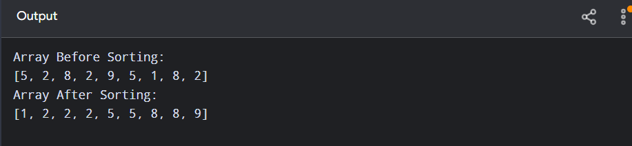

Result:
Thus, the Insertion Sort algorithm was successfully implemented on an array containing duplicate elements, and the array was sorted correctly with its time complexity analyzed.

